Pizza & Grill
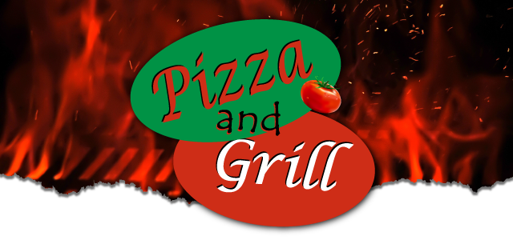

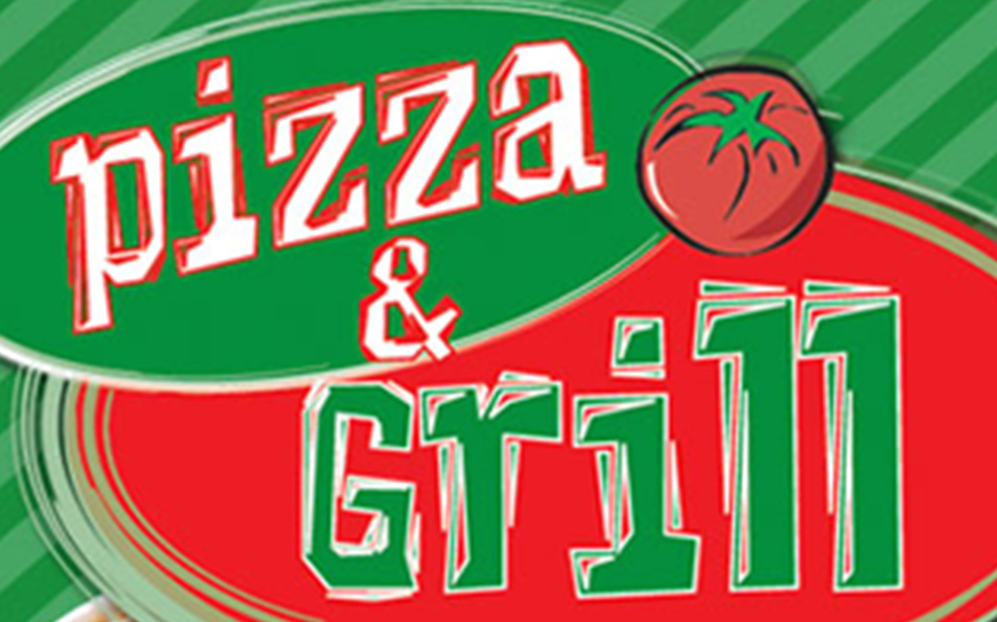
LOCATION

990 Lincoln St., Denver CO 80203
(303) 729-1640

https://pizzaandgrill.ordersnapp.com/home

DELIVERY
Monday | 10:30 am - 9:45 pm
Tuesday | 10:30 am - 9:45 pm
Wednesday | 10:30 am - 9:45 pm
Thursday | 10:30 am - 9:45 pm
Friday | 10:30 am - 9:45 pm
Saturday | 10:30 am - 9:45 pm
Sunday | 12:00 pm - 9:45 pm

beverages
- Soda$1.99 - $2.99
- Iced Tea$1.99
- Bottled Water$1.99
20oz.
- Lemonade$1.99
2o oz. bottle.

appetizers
- Garlic Bread with Mozzarella and Marinara Sauce$2.99 - $4.99
- French Fries$2.99
- Cheese Quesadilla$5.99
- Chicken Nuggets with Freis$5.99
- Mozzarella Sticks$5.99
- Jalapeno Popper$5.99
- Onion Rings$6.99
- Cheese Bread Sticks with Sauce$6.99
- Chicken Quesadilla$7.99
- Chicken Strips with Fries$6.99
- Potato Skins$6.99
6. Cheddar cheese and sour cream with bacon bits.
- Breaded Mushrooms$6.99
- Breaded Zucchini$6.99
- Nachos Supreme$7.99
Corn chips, sour cream, guacamole, jalapeno, nacho cheese, salsa and taco beef.
- Chili Cheese Fries$7.99
Melted mozzarella and cheddar cheese with green chili.
- Sampler$7.99
Onion rings, zucchini, mushrooms, French fries.
- Six Wings with French Fries$7.99
- 4 Piece Fried Chicken$11.99
with cole slaw & garlic bread

salads
With garlic bread.
- Dinner Salad$4.99
Lettuce, tomatoes and cheddar cheese. With garlic bread.
- Antipasto Salad$8.99
Lettuce, tomatoes, pepperoni, ham, black olives and cheddar. With garlic bread.
- Chef Salad$8.99
Ham, turkey, lettuce, tomatoes, black olives and cheddar cheese. With garlic bread.
- Taco Salad$8.99
Taco meat on lettuce with tomato, sour cream, and cheddar cheese, guacamole and tortilla shell. With garlic bread.
- Crispy Chicken Salad$8.99
Lettuce, breaded chicken, tomato, cheddar cheese. With garlic bread.
- Gyro Salad$8.99
Lettuce, tomato, feta cheese, gyro meat. With garlic bread.
- Chicken Guacamole Salad$8.99
Lettuce, grilled chicken, corn chips, sour cream, guacamole, tomato, green pepper and onion. With garlic bread.
- Grilled Chicken Salad$8.99
Lettuce, grilled chicken, tomato and cheddar cheese. With garlic bread.
- Oriental Chicken Salad$8.99
Lettuce, breaded chicken, chow mein noodles, tomato, almonds, cheddar cheese, oriental dressing. With garlic bread.
- Shrimp Salad$8.99
Lettuce, baby shrimp, tomato, cheddar cheese. With garlic bread.
- Greek Salad$8.99
Grilled chicken, lettuce, tomato, green olives, black olives, feta cheese, Greek vinaigrette dressing. With garlic bread.

pasta
With garlic bread.
- Spaghetti$7.99
With meatballs or sausage. With garlic bread.
- Baked Spaghetti$9.99
With meatballs or sausage. With garlic bread.
- Baked Parmesan$9.99
Chicken, eggplant or veal. With garlic bread.
- Meat Lasagna$9.99
With garlic bread.
- Baked Stuffed Shells$10.99
With garlic bread.
- Baked Ravioli$10.99
Meat or cheese. With garlic bread.
- Baked Manicotti$10.99
With garlic bread.
- Chicken Alfredo$11.99
With broccoli or mushrooms. With garlic bread.
- Shrimp Fettuccini$11.99
With garlic bread.
- Meatballs (6)$9.99
Marinara sauce and mozzarella cheese.

seafood
- Fish Dinner$10.99
Catfish or cod, deep fried. With French fries, garlic bread, and coleslaw.
- Fish and Chips$10.99
With French fries, garlic bread, and coleslaw.
- Shrimp Dinner$10.99
With French fries, garlic bread, and coleslaw.
- Seafood Platter$13.99
1 cod pc.,1 catfish pc., 4 shrimp. With French fries, garlic bread, and coleslaw.

hot subs (choose from 7" or 12" and one side)
With choice of side.
- Buffalo Chicken$7.99 - $10.99
Grilled chicken, buffalo sauce, ranch, onion and green pepper, Swiss cheese. With choice of side.
- Special Steak$7.99 - $10.99
Grilled onion, and green pepper, Italian dressing, cheddar cheese, mayo and jalapeno. With choice of side.
- Chicken$7.99 - $10.99
Grilled onion, and green pepper, Italian dressing, cheddar cheese, mayo and jalapeno. With choice of side.
- Meatball$7.99 - $10.99
Marinara sauce, mozzarella. With choice of side.
- Chicken Parmesan$7.99 - $10.99
Marinara sauce, mozzarella. With choice of side.
- Eggplant Parmesan$7.99 - $10.99
Marinara sauce, mozzarella. With choice of side.
- Veal Parmesan$7.99 - $10.99
Marinara sauce, mozzarella. With choice of side.
- Pizza Sub$7.99 - $10.99
Pepperoni, sausage, pizza sauce and mozzarella. With choice of side.
- Veggie Sub$7.99 - $10.99
Grilled onion, and green pepper, mushroom, black olives, marinra sauce and Swiss. With choice of side.
- Hot Ham and Cheese$7.99 - $10.99
Slice ham, Swiss cheese and mayo. With choice of side.
- Fish Sub$7.99 - $10.99
Tarter sauce, lettuce, tomato, Swiss. With choice of side.
- Sausage$7.99 - $10.99
Grilled onion, and green pepper, marinara sauce and Swiss. With choice of side.
- Philly Steak$7.99 - $10.99
Real steak meat, onion, green pepper and Swiss. With choice of side.
- Italian Steak and Cheese$7.99 - $10.99
Sliced steak, grilled onion and green pepper, marinara sauce and Swiss. With choice of side.
- French Dip with Cheese$7.99 - $10.99
Served with au jus. With choice of side.
- Gyro$7.99
Gyro meat, pita bread, onion, tomato, tzatziki sauce. With choice of side.
- New York Strip$9.99 - $15.99
6oz. New York strip, Swiss, grilled onions and mushrooms. With choice of side.
- Rueben Sandwich Hot Sub$7.99 - $10.99
Corned beef, sauerkraut, thousand island, and swiss
- Special Chicken$7.99 - $10.99
Grilled onion, and green pepper, Italian dressing, cheddar cheese, mayo and jalapeno. With choice of side.

cold subs (choose from 7" or 12" and one side)
With choice of side.
- Ham Cold Sub$7.99 - $10.99
Ham, lettuce, tomato, mayo, Swiss. With choice of side.
- Club Cold Sub$7.99 - $10.99
Ham, turkey, bacon, lettuce, tomato, mayo and Swiss. With choice of side.
- Italian Cold Sub$7.99 - $10.99
Ham, pepperoni, tomato, lettuce, mayo, Italian dressing, Swiss. With choice of side.
- BLT Cold Sub$7.99 - $10.99
Turkey Bacon, lettuce, tomato, mayo, Swiss. With choice of side.
- Turkey Cold Sub$7.99 - $10.99
Turkey, lettuce, tomato, mayo, Swiss. With choice of side.
- Roast Beef Cold Sub$7.99 - $10.99
Roast beef, lettuce, tomato, mayo and Swiss. With choice of side.
- Rueben Cold Sub$7.99 - $10.99
Corned Beef, cole slaw, thousand island, and swiss

burgers
Made with 1/2lb of Angus beef, lettuce, tomato, pickle, ketchup, mayo and mustard on the side. Choice of side.
- Chicken Burger$6.99
Made with 1/2lb of Angus beef, lettuce, tomato, pickle, ketchup, mayo and mustard on the side. Choice of side.
- Hamburger$6.99
Made with 1/2lb of Angus beef, lettuce, tomato, pickle, ketchup, mayo and mustard on the side. Choice of side.
- Cheeseburger$7.49
Made with 1/2lb of Angus beef, lettuce, tomato, pickle, ketchup, mayo and mustard on the side. Choice of side.
- Bacon Cheeseburger$7.99
Made with 1/2lb of Angus beef, lettuce, tomato, pickle, ketchup, mayo and mustard on the side. Choice of side.
- Mushroom Swiss Burger$7.99
Made with 1/2lb of Angus beef, lettuce, tomato, pickle, ketchup, mayo and mustard on the side. Choice of side.
- Guacamole Burger$7.99
Made with 1/2lb of Angus beef, lettuce, tomato, pickle, ketchup, mayo and mustard on the side. Choice of side.
- Double Deck$10.99
Double meat and cheese. Made with 1/2lb of Angus beef, lettuce, tomato, pickle, ketchup, mayo and mustard on the side. Choice of side.
- Grilled Chicken Burger$7.99

buffalo wings
- Buffalo Wings$3.99 - $34.99

cheese pizza
- Cheese Pizza$6.00 - $9.00

pizza combos
- Hawaiian Pizza$9.99 - $15.99
Pineapple, ham, extra cheese.
- Meat Lovers Pizza$9.99 - $15.99
Sausage, ham, beef, pepperoni.
- Most Wanted Pizza$9.99 - $15.99
Onion, green pepper, mushroom, pepperoni, sausage.
- Veggie Lovers Pizza$9.99 - $15.99
Green pepper, onion, mushrooms, black olives and tomatoes.

house specialty pizza
- Basil Pizza$13.99 - $18.99
Chicken, basil sauce, tomato, mozzarella cheese, Italian spices.
- Shrimp Scampi Pizza$13.99 - $18.99
Shrimp, scampi sauce, garlic, tomato, mozzarella cheese.
- Greek Pizza$13.99 - $18.99
Chicken, banana peppers, onion, black and green olives, feta and mozzarella cheese.
- Alfredo Pizza$13.99 - $2.99
Breaded chicken or spinach, alfredo sauce, garlic, onion, tomato, mozzarella cheese.
- Marco Polo Pizza$13.99 - $18.99
Breaded chicken, white sauce, onion, green pepper, tomato, Italian spices, mozzarella.
- Philly Steak Pizza$13.99 - $18.99
Steak, white sauce, onion, green pepper, Italian spices, mozzarella and cheddar cheese.
- Taco Pizza$13.99 - $18.99
Taco sauce, taco beef, jalapeno, mozzarella and cheddar cheese topped with lettuce and tomato.
- Chicken Ranch Pizza$13.99 - $18.99
Chicken, ranch sauce, garlic, bacon, onion, tomato, mozzarella and cheddar cheese.
- Spinach Pizza$13.99 - $18.99
Spinach, white sauce, onion, green pepper, Italian spices, mozzarella and cheddar cheese.
- BBQ Chicken Pizza (Whole Pizza Only)$13.99 - $18.99
Breaded chicken, garlic, onion, tomato, bacon, mozzarella and cheddar cheese.
- Buffalo Chicken Pizza (Whole Pizza Only)$13.99 - $18.99
Breaded chicken, garlic, onion, tomato, bacon, mozzarella and cheddar cheese.

calzones
Made with fresh dough, ricotta cheese, mozzarella, garlic, blend of Italian spices, served with homemade marinara sauce.
- All Meat Calzone$9.99
Pepperoni, sausage and beef. Made with fresh dough, ricotta cheese, mozzarella, garlic, blend of Italian spices, served with homemade marinara sauce.
- Super Calzone$9.99
Pepperoni, sausage, green peppers and onion. Made with fresh dough, ricotta cheese, mozzarella, garlic, blend of Italian spices, served with homemade marinara sauce.
- Chicken Calzone$9.99
Chicken, green pepper and onion. Made with fresh dough, ricotta cheese, mozzarella, garlic, blend of Italian spices, served with homemade marinara sauce.
- Spinach Calzone$9.99
Spinach, onion, green pepper. Made with fresh dough, ricotta cheese, mozzarella, garlic, blend of Italian spices, served with homemade marinara sauce.
- Meatball Calzone$9.99
Meatballs, green peppers and onion. Made with fresh dough, ricotta cheese, mozzarella, garlic, blend of Italian spices, served with homemade marinara sauce.
- Vegetable Calzone$9.99
Onion, mushrooms, black olives, green peppers. Made with fresh dough, ricotta cheese, mozzarella, garlic, blend of Italian spices, served with homemade marinara sauce.
- My Calzone$9.99
Pick any 3 toppings. Made with fresh dough, ricotta cheese, mozzarella, garlic, blend of Italian spices, served with homemade marinara sauce.

stuffed bread
Giant pizza pocket made with fresh dough, blend of Italian spices, garlic and served with homemade marinara sauce.
- Spinach Stuffed Bread$7.99
Spinach, garlic, and mozzarella cheese. Giant pizza pocket made with fresh dough, blend of Italian spices, garlic and served with homemade marinara sauce.
- Pepperoni Stuffed Bread$7.99
Pepperoni, garlic, and mozzarella cheese. Giant pizza pocket made with fresh dough, blend of Italian spices, garlic and served with homemade marinara sauce.
- Chicken Stuffed Bread$7.99
Breaded chicken, garlic and mozzarella cheese. Giant pizza pocket made with fresh dough, blend of Italian spices, garlic and served with homemade marinara sauce.
- Sausage Stuffed Bread$7.99
Sausage, garlic and mozzarella cheese. Giant pizza pocket made with fresh dough, blend of Italian spices, garlic and served with homemade marinara sauce.
- Meatball Stuffed Bread$7.99
Meatballs garlic and mozzarella cheese. Giant pizza pocket made with fresh dough, blend of Italian spices, garlic and served with homemade marinara sauce.
- My Stuffed Bread$7.99
Choose of one topping. Giant pizza pocket made with fresh dough, blend of Italian spices, garlic and served with homemade marinara sauce.
- Hawaiian Stuffed Bread$8.99
Ham, pineapple, garlic and mozzarella cheese. Giant pizza pocket made with fresh dough, blend of Italian spices, garlic and served with homemade marinara sauce.

mexican dishes
- Big Beef Soft Taco$2.99
1. Cheese, lettuce, tomato and sour cream.
- Big Chicken Soft Taco$3.99
1. Cheese, lettuce, tomato and sour cream.
- Beef Hard Tacos$4.99
4. Cheese, lettuce and tomato.
- Burrito Giante$6.99
Beef or chicken, cheddar, grilled onion and green pepper, rice, beans and sour cream.
- Beef and Bean Burrito Supreme$9.99
Smothered.
- Chicken and Bean BUrrito Supreme$9.99
Smothered.
- Enchilada$9.99
Beef, chicken or cheese. Smothered.
- Mexican Burger$9.99
Smothered.
- Chimichanga$9.99
Chicken or beef. Smothered.
- Chili Relleno Dinner$9.99
Smothered.
- Tamale$9.99
Smothered.

indian dishes
- Vegi Samosa$1.99
- Chicken Curry$9.99
With rice and chutney.
- Chicken Tikka Masala$9.99
With rice and chutney.
- Chicken Biryani$9.99
With rice and chutney.
- Naan$1.99

desserts
- NY Style Cheesecake$4.99
- Chocolate Chip Cheesecake$4.99
- Raspberry Swirl Cheesecake$4.99
- Chocoalte Cake$4.99
- Ice Cream by the Pint (Flavor of the Week)$5.99

