Finding InDesign on your Desktop

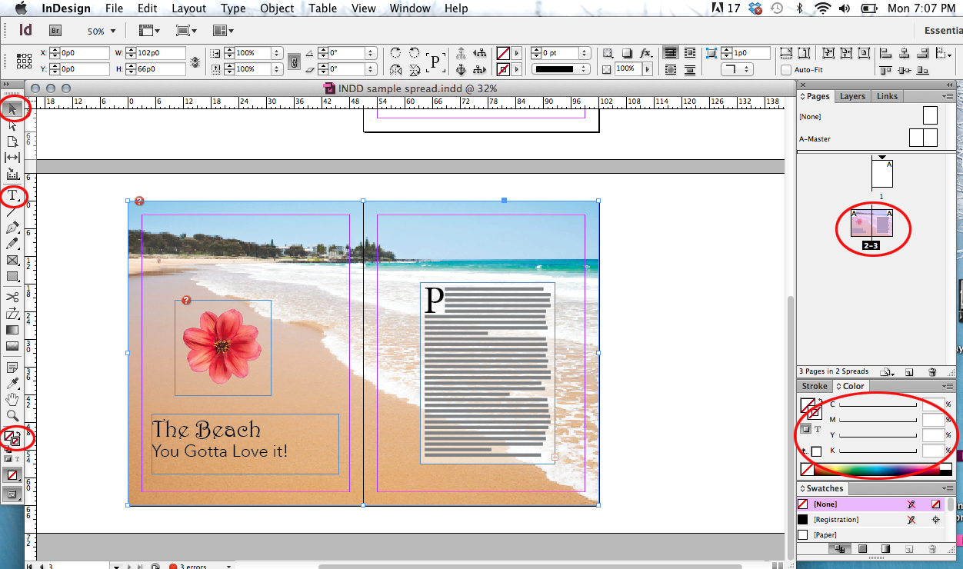
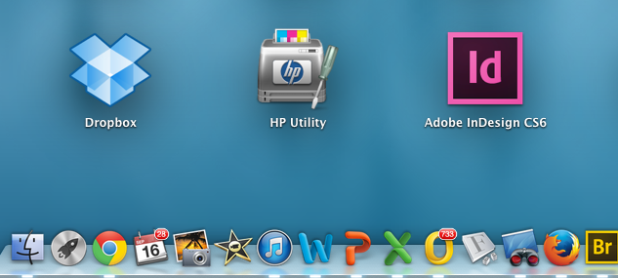
The Indesign (ID) User Interface

Selection Tool: allows you to select items on the pasteboard.

Type tool: Allows you to add text.

Pages: a diagram of all the pages in your document. You need to have 3 page so that pages 2 and 3 are next to each other.

Fill Color: Fills a shape with color
Stroke Color: Puts a colored border around a shape.
To Find InDesign go to the Launch button on your dock (usually at the bottom of the page). Look for the Id pink and black button. It might be on the first desktop page or the second.
Creating an Editorial Spread (2 pages next to each other) in ID
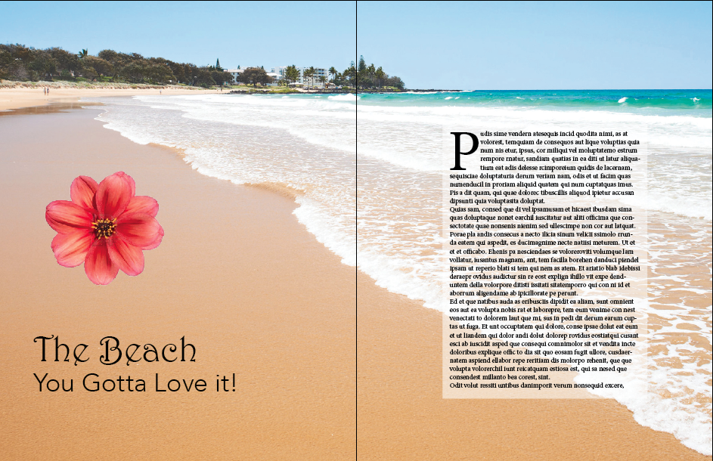 | What you are creating:  In order to learn how to use InDesign to create your profile article follow the steps here for the basics you will need to know.  After this, experiment, explore, look things up and design an interesting looking article.
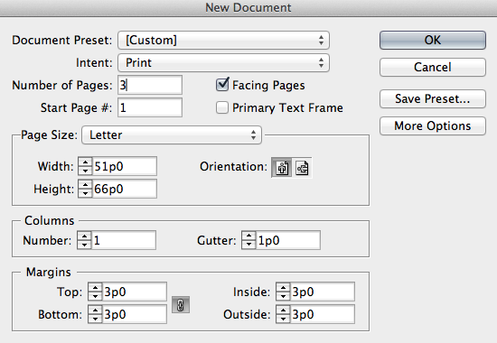 | Step 1: Open Indesign  Step 2: Create a new document using the settings in the image on the left.
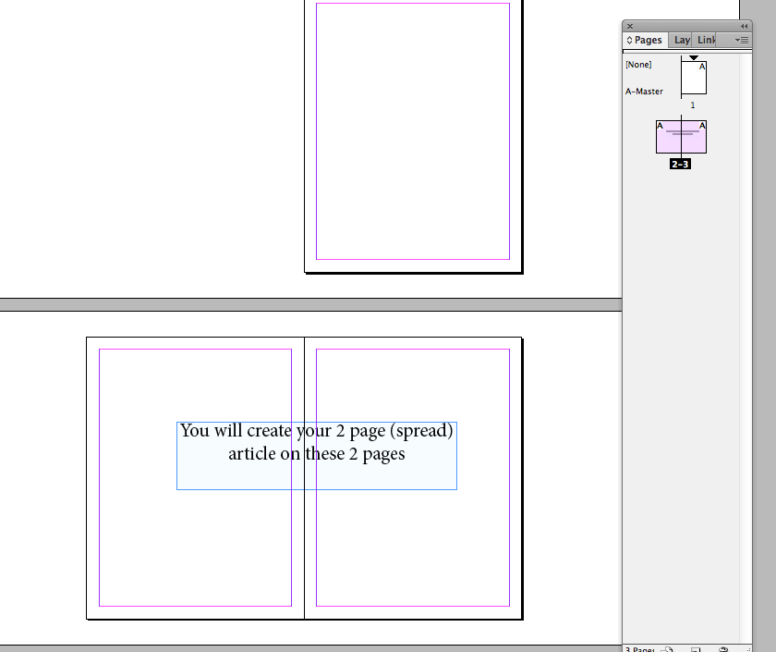 | Step 3: Indesign will create 3 pages. You will only be working on the 2 pages that are next to each other as in the image on the left.  Adjust your page size by zooming in and out.  Enlarge your page view: cmd>+  Reduce your page view: cmd>-  You can see a mini-view of your pages on the floating palette on the right.
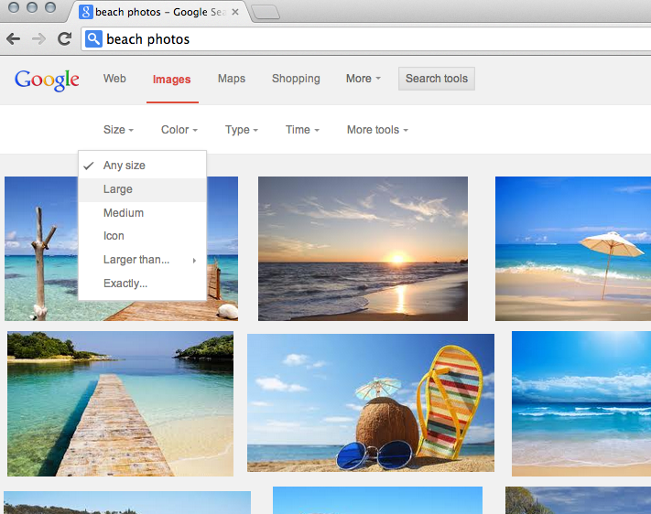 | Step 4: Find a large background image. To do this go to Google>Images>Size and choose large.  If you don’t find a large image your background image will pixilate when enlarged and look terrible.  *You do not have to find the background image that I used but you can if you want.
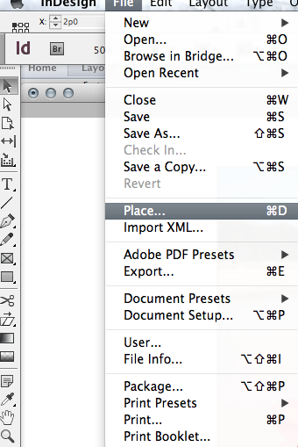 | Step 5: In ID, go to File>Place (see left) and browse to the background image you found.  Place your image at the very up left of your page and click.  Your image will probably run off the page. In the next step you will learn how to resize it.
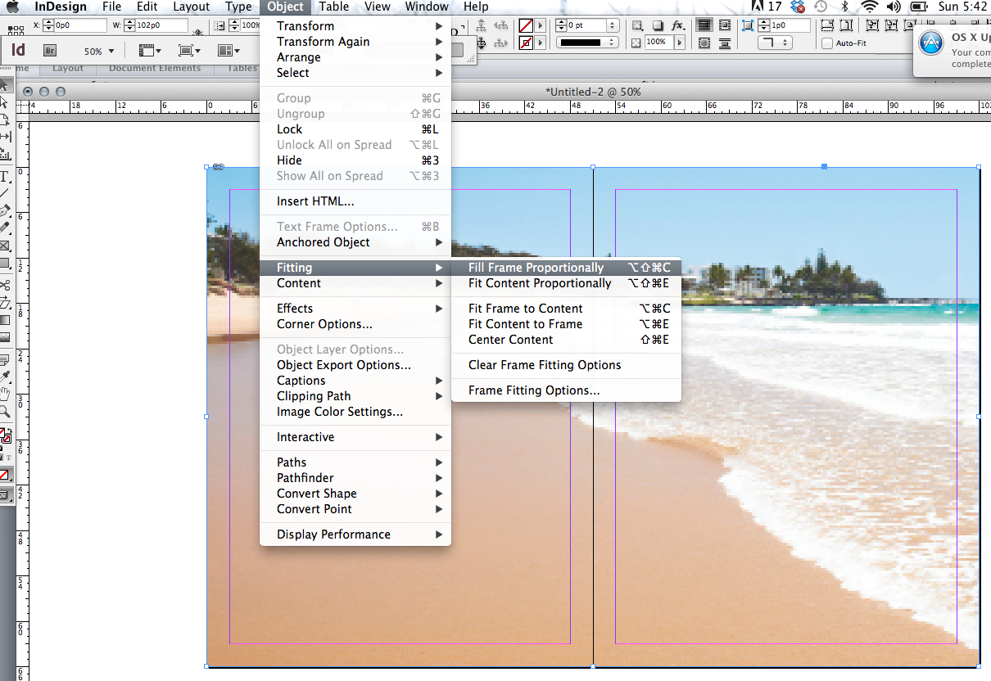 | Resize your background Photo  Step 6: Resize your background. First grab the bottom right corner and bring it up to match the outside rectangle of your pages.  Your image WILL NOT RESIZE like it does in Word. That’s ok.  Go to: Object>Fitting>Fill Frame Proportionately (see left)  This will make your fit as well as it can inside your two page spread.  **Make sure to save your document Often  If your background photo looks pixelated or blurry see the instructions of page 8 of this document.
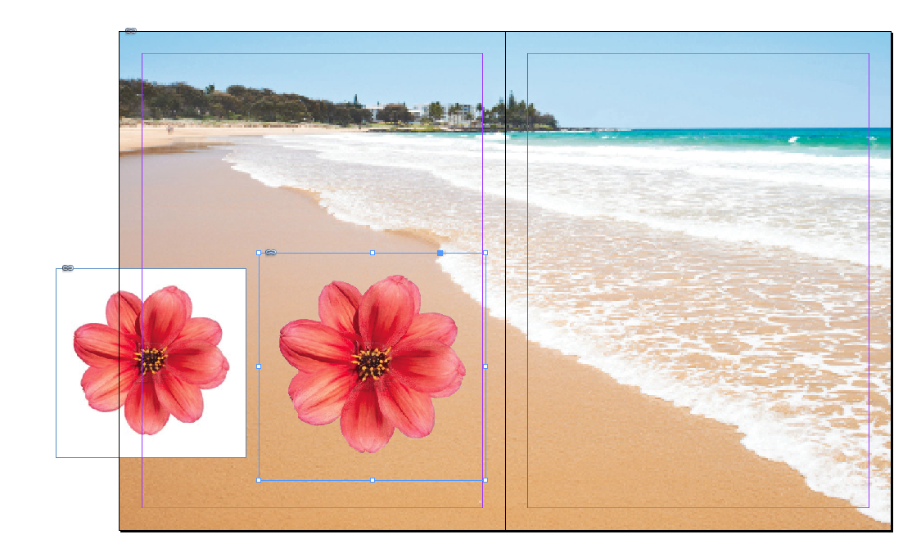 | Cutting out Backgrounds in Photoshop  Sometimes you will want to use an image—but not it’s background. This is when designers may use more than one program.  Photoshop is the best way to cut out backgrounds. Images that are against a white background (see left) are the easies.  Open your image in Photoshop. Unlock the background image by double clicking on it (then selecting OK). This allows you to remove the background pixels. Use the magic wand tool and select the white background. PS should select all of the the pixels that are white. Then click delete.  Make sure to save your document as a .psd so that it preserves the transparent background.  Place image in ID. The background will not be there like in the image on the left.
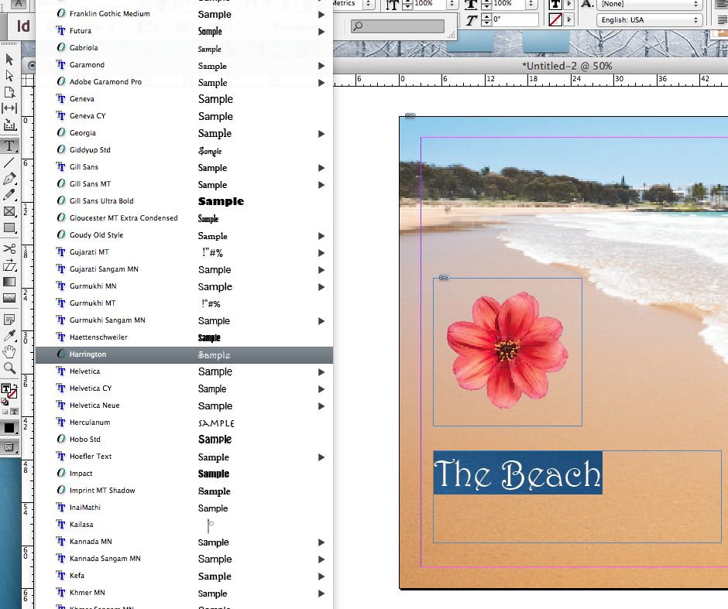 | Adding Text  To add a text box to you layout, choose the “T” text tool and draw a box where you want your text to be.  To change the type size and style, select Type (up top) and Font and size is the first to things on the drop down menu.  To change size you can also use the keyboard commands:  Bigger type: Cmd/shift and >  Smaller type: Cmd/shift and <  To change the color, select the type you want to change and double click on the color picker at the bottom of the tool bar to choose a new color. The square with the T must be on top.
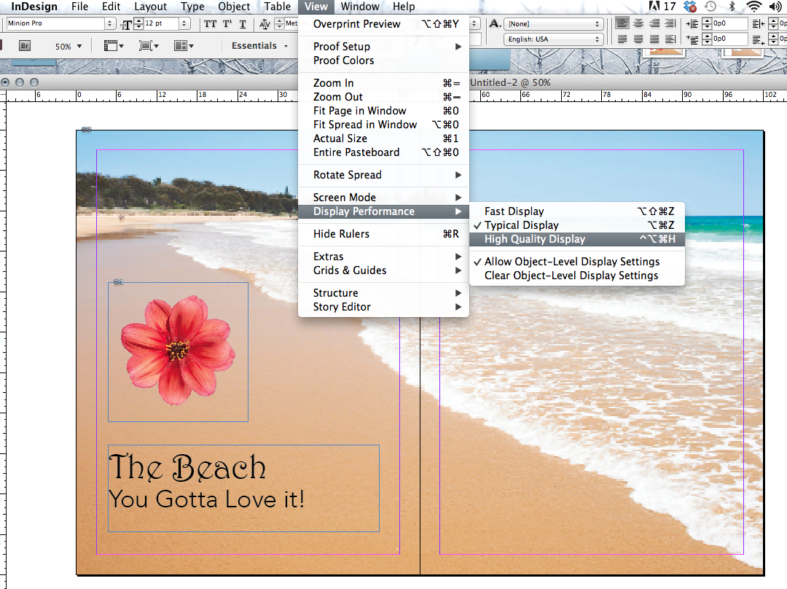 | A Note about the Appearance of your Background Image  If your background image seems very pixilated or blurry, that is because ID does that so that you can work faster.  If you want to change that go to:  View>Display Performance>High Quality Display (see left)  This will make your background image look much better provided is big enough to begin with.  **Make sure to save your document Often
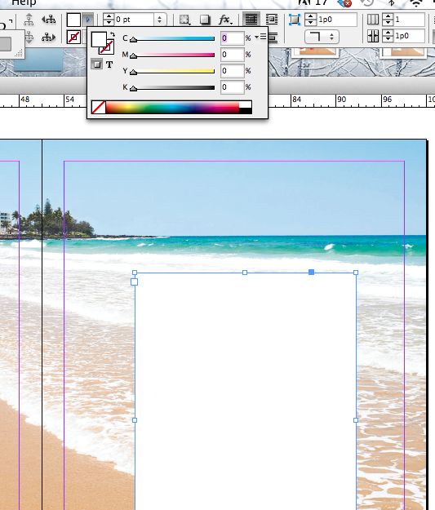  Use the shift key to get this box | Creating a Text Box for the Words of your Article  All text will be in a text box. Usually that text box is clear so that you can see through it, but if you are putting text on a photo, you might need to make your text box a color so that you can read your text.  Using the “T” tool on the left bar, draw a text box where you want it  On the top, you will see a box that if you hover over it, it says “fill.”  Press shift and click on the little arrow and you will see a color box like on the left.  Now you have a white box to put your text into.  **Make sure to save your document Often
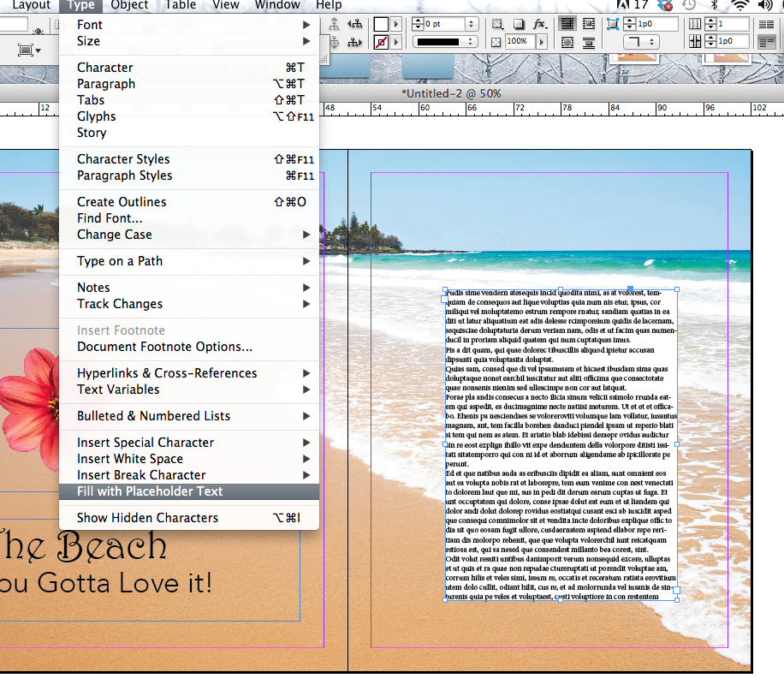 | Add Placeholder Text to your Page  Designers often need to do design work before they have actual words (called copy). When this is the case they add Placeholder text. To do this  Select your text box and go to Type>Fill with Placeholder text (see the drop down box on the left)  This will fill your text box with nonsense text to just give your page the “look” of having text.  **Make sure to save your document Often
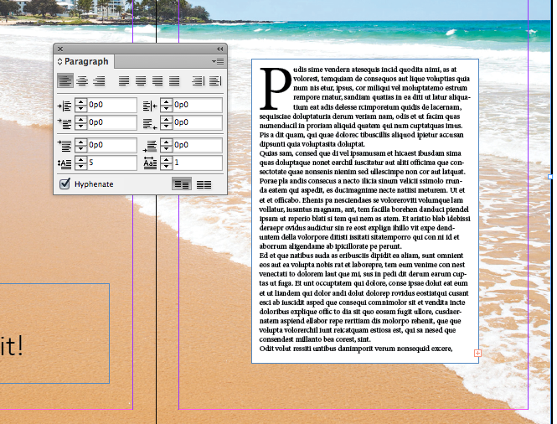 | Add a Drop Cap to your Page  To make the large P like on the left, select the text box, go to Type (on the top) and select Paragraph. You will get a floating box like on the left. Type in the number of lines you want your Drop Cap to take up. I made mine 5.  Pull your text away from the edges of the box.  You never want your text to touch the edge of a box so you are going to use Inset Spacing to create this space.  Select the text box with the arrow tool. Then right click on the box OR use Cmd B which is Text Frame Options. In the menu make all the Inset Spacing margins to 1p. This means 1 pica, which is a design measurement that is a little less than ¼ inch.  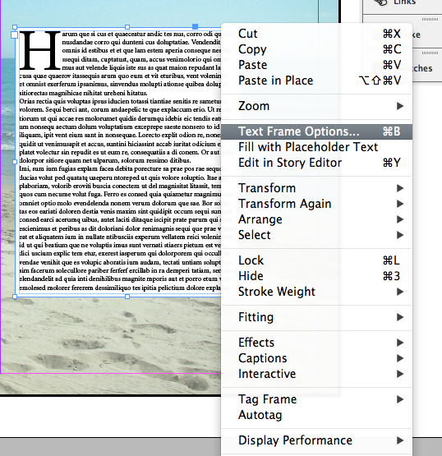
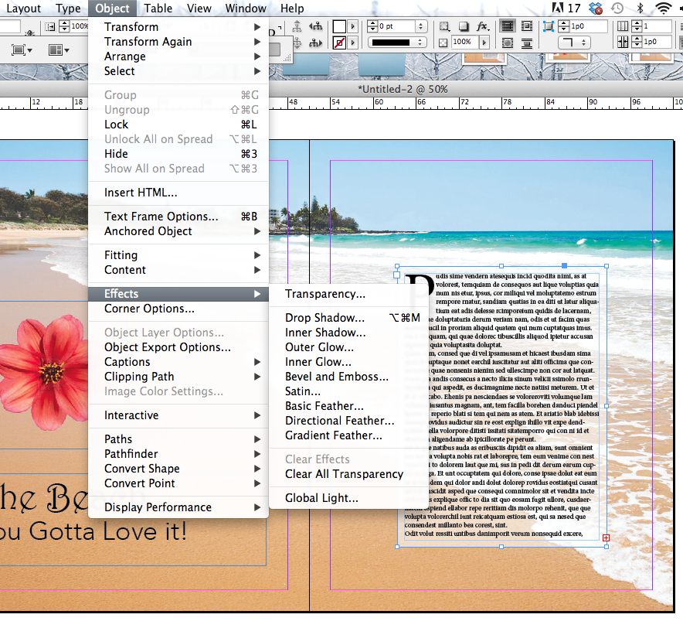 | Making Your Text box a Little Bit  Transparent  Sometimes you might want to see a little bit of the background image through your text box. To do this go to Object>Effects>Transparency. Choose “Fill” in the Settings For: box and then change your Opacity to a percentage. 50% would be half transparent. I suggest something like 60% so that you can see the waves but yet your text is still readable.  **Make sure to save your document Often
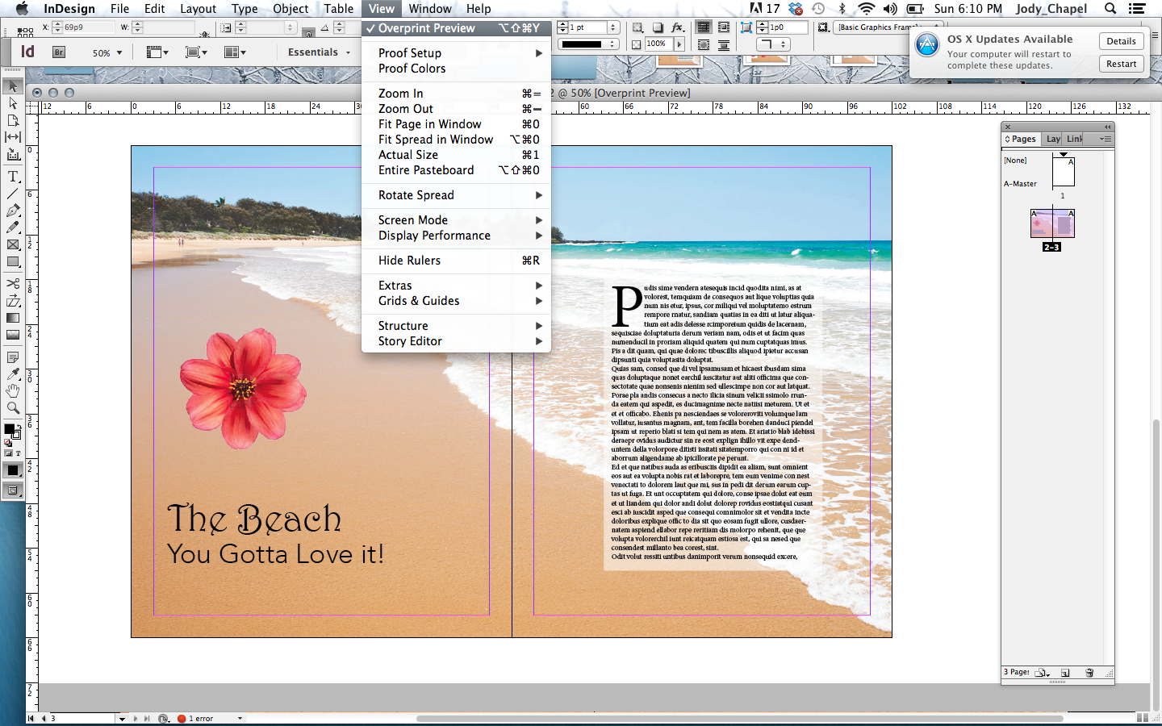 | See What Your Image Looks Like  Now you will want to see your pages without all the guidelines.  - View>Overprint Preview  - View>Grids & Guides>Hide Guides  Make sure to save your document to turn in. Save As:  YourName_IDtutorial.indd  Put it in our class drop box in the appropriate folder to get credit for your hard work!

